

**BLOCK 4B**

**BACHELOR OF SCIENCE IN INFORMATION TECHNOLOGY**

**CLEARBOOK**

S.Y. 2025 - 2026

MAE ANN D. ABELLON

**CLASS MAYOR**

PROCORO V. GONZAGA

**CLASS ADVISER**

SR. JOSEPHINE D. ATIVO A.R.

**SCHOOL PRINCIPAL**

**CCTC**

**VISION & MISSION**

**VISION**

**CONSOLATRIX COLLEGE INVISIONS A LIFE-GIVING INNOVATING EDUCATION MINISTRY COMMITTED TO TRANSFORMING COMMUNITY OF LEARNERS INTO CHRIST-CENTERED AUGUSTINIAN RECOLLECT STEWARDS.**

**MISSION**

1. STRENGTHEN FRATERNAL CHARITY THROUGH GOD FILLED FRIENDSHIP AND RENEWED EVANGELIZATION.
2. FACILITE THE INTEGRAL DEVELOPMENT OF THE LEARNERS TOWARDS TRANSFORMATION THROUGH CURRENT RESEARCHES, RELEVANT CURRICULAR OFFERINGS AND RESPONSIVE COMMUNITY EXTENSION SERVICES.
3. FORTIFY LEADERSHIP AND PROFESSIONAL DEVELOPMENT OF STAKEHOLDERS THROUGH CONTINUING EDUCATION AND INTENSIVE AUGUSTINIAN RECOLLECT SPIRITUALITY.
4. DEVELOP A COMMUNITY OF A CHRIST-CENTERED AUGUSTINIAN RECOLLECT STEWARDS, WHO ARE ENVIRONMENTALLY CARING AND GLOBAL LEADERS.
5. NURTURE ONE ANOTHER IN THE SHARED MISSION FOR THE SUSTAINABILITY OF THE A.R. SCHOOLS AND SOCIAL RELEVANCE OF PROGRAM AND SERVICES.

**LIST OF CLASS OFFICERS**



 MAE ANN ABELLON JOAHNESS CAPARAS

**MAYOR                                          VICE MAYOR**



CATHERINE VENTURES APRIL JOY LORCA

**SECRETARY                                ASSISTANT SECRETARY**



EMIE GRACE ESTRELLA LYCA MAE LACSON

**TREASURER                              ASSISTANT TREASURER**



KATE MONTILLA JOSHUA PAPELLERO

**AUDITOR PRO**



 KENT EZEKIEL VILLAHERMOSA

**PRO**

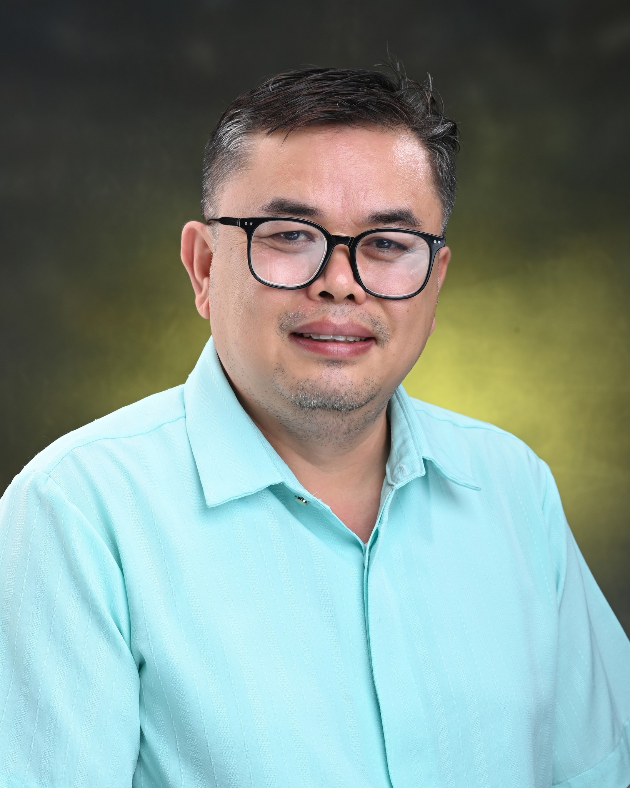

MR. PROCORO V. GONZAGA

**CLASS ADVISER**

**BLOCK 4B**

**BACHELOR OF SCIENCE IN INFORMATION TECHNOLOGY**

**LIST OF CLASS MEMBERS**

**S.Y.: 2025 - 2026**

**BOYS**

1. Barnido, Laurence Panilag
2. Baron, Clint Dimco
3. Caparas, Joahness Masayon
4. Caparida, Jan Niño Beceril
5. Cornelio, Hans Christian Kilaton
6. Dalogdog, Roque Alolor
7. Dazo, Genesis Abayon
8. Dejoras, Emmanuel Amores
9. Dela Cerna, Jan Khalil Canillo
10. Estrella, James Angelo Longakit
11. Gako, Christian Jee Rico
12. Gorgonio, Kharl Nexus De Gracia
13. Itong, Kent Neil Borgonia
14. Lapis, John Kinon Cajes
15. Macaday, Ian Dave
16. Mahinay, Robert Ortilano
17. Mission, Van Exel Juarez
18. Orbeta, Rey Bacalso
19. Papellero, Joshua Atillo
20. Pasilan, Shan Paul Diotay
21. Pontiñela, Francis Emmanuelle Langgamon
22. Purisima, Clark Niño Bacus
23. Rafaela, John Ray Naranja
24. Rico, James Bryle Rasola
25. Rubio, Andrey Cabrigas
26. Toring, Jeremiah Cabahug
27. Ugdiman, Kent Salvador
28. Villahermosa, Kent Ezekiel Rañoa

**GIRLS**

1. Abellon, Mae Ann Dolino
2. Castillo, Rechiel Gitutua
3. Estrella, Emie Grace Tingal
4. Gemelo, Fretzie Rubin
5. Hoyohoy, Divina Mahilum
6. Lacson, Lyca Mae Ibañez
7. Landongan, Jken Segarra
8. Lorca, April Joy Caliguid
9. Montilla, Kate
10. Nabalitan, Ma. Leah Alexa Dulap
11. Rosanto, Julianne Alicabo
12. Silvosa, Nova Gemina
13. Ventures, Catherine Birao
14. Yongco, Quennie Hazen

**MONTH OF**

**JUNE**

***NARRATIVE REPORT***

**FIRST DAY OF SCHOOL**

The first day of school for the academic year 2025–2026 was held on June 9, 2025. Students from all levels gathered in the covered court to join the opening activity prepared by the school administration. Excitement filled the air as students reunited with their classmates and looked forward to meeting their new teachers.

For the 4th Year BSIT Block B, most of us were present to experience the opening day. We participated in the welcoming activities and joined our classmates in meeting our subject teachers. The day also served as a chance to reconnect with friends after the break and to prepare ourselves for the academic challenges ahead.

Only a few of our classmates had already begun their On-the-Job Training (OJT), which meant they could not attend the first day. Despite this, they expressed their support and enthusiasm through messages and updates. For the rest of us who were present, it was a meaningful start to our final year in college, filled with both excitement and anticipation as we balance academics with our OJT responsibilities.



Prepared by: Noted by:

______________________ _______________________

    Joahness Caparas   Mae Ann D. Abellon

**CLASS VICE-MAYOR CLASS MAYOR**

                               Approved by:

                                 ______________________

                                             Procoro V.Gonzaga

**CLASS ADVISER**

***NARRATIVE REPORT***

**ELECTION OF CLASS OFFICERS**

The election of class officers for the academic year 2025–2026 was held in June 2025. This activity aimed to appoint leaders who would represent each class and help maintain order, cooperation, and unity throughout the school year.

Our block, **4th Year BSIT-B**, was fully present during the election. We actively nominated and voted for our classmates to fill different leadership positions such as Class Mayor, Vice Mayor, Secretary, Treasurer, and other key roles. The process was conducted in a fair and organized manner, ensuring that the voices of all students were heard.

The newly elected officers pledged to serve the class with responsibility and dedication, while the rest of the block expressed support for their leadership. This event marked the beginning of stronger cooperation within our class as we entered our final year in college.



Prepared by: Noted by:

______________________ _______________________

     Joahness Caparas   Mae Ann D. Abellon

**CLASS VICE-MAYOR CLASS MAYOR**

                               Approved by:

                                 ______________________

                                             Procoro V.Gonzaga

**CLASS ADVISER**

**MONTH**

**OF**

**JULY**

***NARRATIVE REPORT***

**FEAST DAY OF MT. CARMEL**

Date: July 16, 2025  
  
On July 16, 2025, the Feast of Our Lady of Mount Carmel was solemnly celebrated at Consolatrix College. A Eucharistic mass was held in honor of the Blessed Virgin Mary, which was attended by both students and faculty.  
  
Our block, BSIT 4B, was not present physically because of OJT, but we shared in the celebration by offering our prayers for guidance and strength as we continue both our academic and professional training. This celebration reminded us of the value of faith, devotion, and gratitude as we face challenges.



Prepared by: Noted by:

______________________ _______________________

     Joahness Caparas   Mae Ann D. Abellon

**CLASS VICE-MAYOR CLASS MAYOR**

                               Approved by:

                                 ______________________

                                             Procoro V.Gonzaga

**CLASS ADVISER**

***NARRATIVE REPORT*  
  
NUTRITION MONTH**

Date: July 31, 2025  
  
The Nutrition Month celebration took place on July 31, 2025, highlighting the importance of health and proper diet among students. Several activities such as cooking competitions, poster-making, and informative talks were organized to encourage awareness of healthy living.  
  
Although our block was unable to fully attend due to OJT, we still recognized the value of this event as IT students, since balancing academic, professional, and health priorities is essential for productivity. We admired the creativity and efforts of those who joined the contests and promoted the advocacy for wellness.



Prepared by: Noted by:

______________________ _______________________

     Joahness Caparas   Mae Ann D. Abellon

**CLASS VICE-MAYOR CLASS MAYOR**

                               Approved by:

                                 ______________________

                                             Procoro V.Gonzaga

**CLASS ADVISER**

**MONTH**

**OF**

**AUGUST**

***NARRATIVE REPORT*  
  
BUWAN NG WIKA AND ASEAN CELEBRATION**

Date: August 28–29, 2025  
  
On August 28–29, 2025, the school celebrated Buwan ng Wika and ASEAN 2025. Students proudly showcased their talents through cultural performances, speeches, and presentations. Wearing traditional attire, they honored the Filipino language and heritage while also learning more about the ASEAN community.  
  
As 4th Year BSIT-B, most of us were not able to participate because of our OJT. However, we appreciated how the event strengthened the students’ identity as Filipinos while promoting unity with our ASEAN neighbors.



Prepared by: Noted by:

______________________ _______________________

     Joahness Caparas   Mae Ann D. Abellon

**CLASS VICE-MAYOR CLASS MAYOR**

                               Approved by:

                                 ______________________

                                             Procoro V.Gonzaga

**CLASS ADVISER**

***NARRATIVE REPORT*  
  
FEAST DAY OF ST. AUGUSTINE**

Date: August 28, 2025  
  
The Feast Day of St. Augustine was observed on August 28, 2025, with a solemn mass and reflection on his teachings. Students and faculty gathered to celebrate the wisdom of St. Augustine and his contributions to the Church.  
  
Although BSIT 4B students were absent due to OJT, we took time to reflect on the values of humility, perseverance, and learning—virtues that St. Augustine embodied and which are also important in our journey as graduating students.



Prepared by: Noted by:

______________________ _______________________

     Joahness Caparas   Mae Ann D. Abellon

**CLASS VICE-MAYOR CLASS MAYOR**

                               Approved by:

                                 ______________________

                                             Procoro V.Gonzaga

**CLASS ADVISER**

**MONTH**

**OF**

**SEPTEMBER**

***NARRATIVE REPORT*  
  
FEAST DAY OF THE NATIVITY OF THE BLESSED VIRGIN MARY**

Date: September 8, 2025  
  
On September 8, 2025, Consolatrix College celebrated the Feast of the Nativity of the Blessed Virgin Mary. A holy mass and simple festivities were held to honor the birth of Mary, the mother of Jesus.  
  
Although our block could not join because of OJT, we remained spiritually connected by offering prayers for guidance and protection. This celebration reminded us of the importance of faith in balancing academics, work, and personal life.



Prepared by: Noted by:

______________________ _______________________

     Joahness Caparas   Mae Ann D. Abellon

**CLASS VICE-MAYOR CLASS MAYOR**

                               Approved by:

                                 ______________________

                                             Procoro V.Gonzaga

**CLASS ADVISER**

***NARRATIVE REPORT*  
  
DRUG AWARENESS AND PENOLOGY DRIVE**

Date: September 8, 2025  
  
The school conducted a Drug Awareness and Penology Drive on September 8, 2025. The program aimed to educate students about the dangers of drug abuse and the importance of discipline and law-abiding behavior. Guest speakers and experts shared insights to spread awareness among the youth.  
  
Although BSIT 4B could not fully attend due to OJT, we support the advocacy against illegal drugs and recognize the importance of awareness campaigns in promoting a safe and responsible community.



Prepared by: Noted by:

______________________ _______________________

     Joahness Caparas   Mae Ann D. Abellon

**CLASS VICE-MAYOR CLASS MAYOR**

                               Approved by:

                                 ______________________

                                             Procoro V.Gonzaga

**CLASS ADVISER**

***NARRATIVE REPORT*  
  
INTRAMURALS 2025**

Date: September 10, 2025  
  
On September 10, 2025, the school Intramurals began with a festive parade and the lighting of the torch. Students from different departments competed in various sports, cheering for their respective teams with energy and pride.  
  
As 4th Year IT students in OJT, we were unable to join the games, but we still showed our support by cheering online and congratulating our fellow students for their sportsmanship. This event showcased unity, camaraderie, and the spirit of healthy competition.



Prepared by: Noted by:

______________________ _______________________

     Joahness Caparas   Mae Ann D. Abellon

**CLASS VICE-MAYOR CLASS MAYOR**

                               Approved by:

                                 ______________________

                                             Procoro V.Gonzaga

**CLASS ADVISER**

***NARRATIVE REPORT*  
  
SCIENCE AND MATH MONTH**

Date: September 2025  
  
The Science and Math Month was celebrated in September 2025 with activities such as quiz bees, experiments, poster-making, and exhibits. The event aimed to encourage students to appreciate the importance of science and mathematics in everyday life and in their future careers.  
  
Although our block was not able to attend because of OJT, as BSIT students we recognize the role of science and math as the backbone of technology. We commend the participants who showcased their skills and knowledge during the celebration.



Prepared by: Noted by:

______________________ _______________________

     Joahness Caparas   Mae Ann D. Abellon

**CLASS VICE-MAYOR CLASS MAYOR**

                               Approved by:

                                 ______________________

                                             Procoro V.Gonzaga

**CLASS ADVISER**